**Date:** 21/10/2024 20:00 to 21:00

**Attendance:** Phát, Đức, Huy

Phát, Đức re-evaluate the current ideas of the database and modified the database according to the new erd design that the TA suggested.

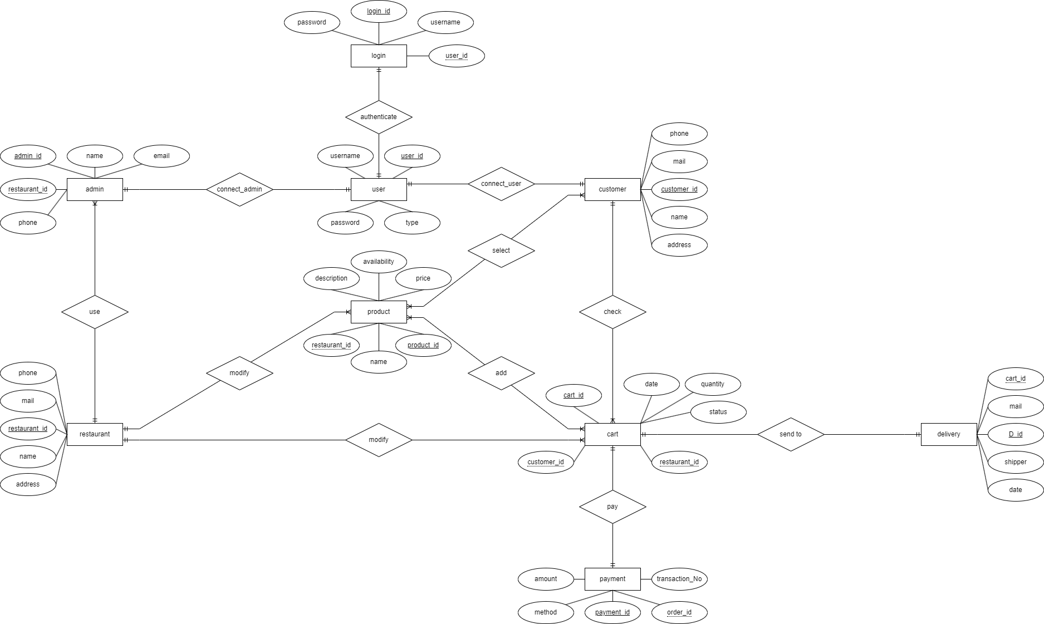

Update the progress of the report along with the web design